- Is your project related to the work of teachers, PhD students or programme objectives of the Amsterdam School?

(Note: The italic words are from the exact sentences of the AISSR website about the program of Dynamics of Citizenship and Culture)
Yes, when I read research lines of the Dynamics of Citizenship and Culture in AISSR website, I found object of its research very near to my M.S. thesis and consequently this PhD program. Especially the dynamic of the conflict between the youth groups in the urban cities, struggle for protection from their communities, its solidarity or values against the immoral behaviours of the downtown youth group and specifically having their voices and creation of the meaning for residents of the urban areas are under my focus.
In this way, with consider to the management of place and time by the youth groups of uptown, finding their divers resistance or even spatial tactics against the downtown youth groups and the guards of the shopping complex were the main experiences of my M.S. thesis.
The experiences that one of them shows in these pictures help me for further exploring of the ways that immigrants may use for defining and redefining of their identities in the PhD proposal. Identities that change over and in accordance with the dynamic and spatial movements of the urban population in this thesis have been led to damaging of the uptown lifestyle by the downtown youth groups.

Places for the escape and minimum degree of resistance without any explicit conflict with the guards of shopping complex. When the guards do not allow the uptown youth group to stand or sit in the public spaces of this complex, they shelter and hide themselves in the marginal recourse (blue cadre).
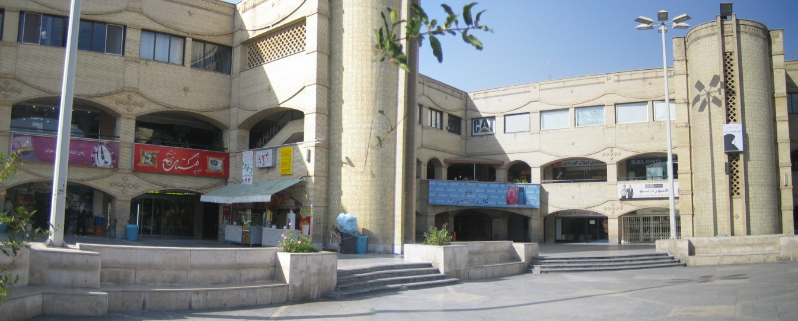
The main location of the guarding by the security guards of the Golestan shopping complex, North of Tehran.
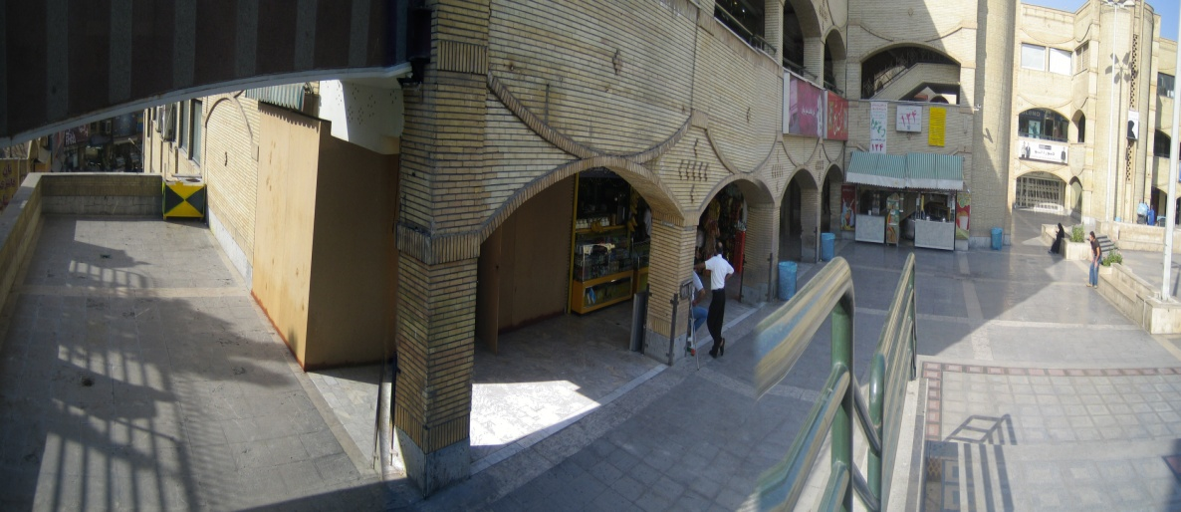

In addition, absolutely, I believed that the construction and reconstruction of their identities as a low class or high class unconsciously was emerged through their real daily life their mobility and conflict with each other. In addition, it is not specified through presuppositions such as newcomers or Muslims that mentioned in details of the PhD program. These real daily lives will be determined as deeper sociological understandings with their narrations from their lived experiences. Accordingly, all of this conflictual story in Tehran can be applied for the urban immigrants only through these deeper sociological understandings. Methodologically, it is possible via their memorial narrations about the history of conflict, the nostalgic memory of the lively times of the before conflict, their time or places for resistance, their identical values and the like.
This situation of the resistance, differentiation and identification can work as opportunity for exploring of the probable networks of solidarity among the immigrants or their urban neighbourhood, something like the networks that issued in research profile of the PhD program. As a reaction to the risky environment of the development and immigration, these looser networks than the traditional families are varied from very aggressive isolated group (ethnocentrism, crime configuration) to more tolerated forms of the responsible citizens such as care network and education support.
Then, the most innovative part of my PhD proposal is the methodology that I want to apply for answering to this question of the Program Group: how they struggle to create meaningful places and to protect or expand their rights?
As an answer, with making and creation of supportive networks of the immigrants the procedure of their integration with the meaningful places (such as resistance in the recourse of shop store, refer to picture) and their belonging to protection or expanding of their rights will be determined.
Theoretically, at the contextual eventuality of the everyday life, memory, its remembrance and permanent recalling of the better past life, is a main foundation for the stable sense of belonging and consequently the creation or protection of the immigrant supportive networks for reproduction of the better past life.
With the qualitative methods, the better past life and its indications are observable and for making of the social networks as a reproduction of the better past life, its social patterns or cultural representations of the better past life must be identified, used, recreated, strengthened, protected and supported.
The most important narratives of the better past life firstly can be observed (e.g. by the survey methods) through the socio-economic dependencies to the old-fashioned social traditions of the better past life such as charity, care and maternal support, traditional housing, the home-made cooking, motherland and its ritual or nature or can be remembered (e.g. by the deep interview methods) through the memorial symbols, heroic storytelling, the lived experiences of political or social freedoms, good memories about the solidarity of civil movements, nostalgic feelings with the old goods, cultural productions or mythical ideas and
Secondly, its lively patterns, its caring essence, its solidarity, its cultural motivation or its sympathetic passions and the like for rebuilding and protection of the immigrant networks as a reproduction of the better past life can be used.
With these phenomenon and specific belongings to the past, the social networks can go beyond of the traditional strict definitions of the culture and citizenship.
Alike with the multilayer definitions of this research program, consciousness and remembrance of better past life as shared processes of meaning making and reusing of them for the reconfiguration and the reorientation may lead to rebuilding and protection of the immigrant networks that is in accordance with the widespread definition of culture in this research program. On the other hand, with considering to the four dimensions of citizenship, my attention is the real problems of immigrant in these four domains due to dual nature of the citizenship as a collective project and simultaneously an exclusionary process.
Therefore, the culture as shared processes of meaning making and its reorientation is not only the mere remembrance of the past and its sensual motivation, but also its elaborated selective content for resolving of the citizenship problems. For example about the political dimension of the citizenship, the main task of me as a researcher is trying to make an agreement about the main problems of them when the members of immigrant networks – that is created by recalling of their memory-occupy the urban spaces and have a conflict with outsiders and simultaneously wanting them to remember their memories about the better past public spaces (the elaborated selective content of the memory). Agreeing on their common problems with other insider and outsider that based on the better past public spaces (the combined transnational past public spaces) and the necessary rebuilding of it in collaboration with the other insider and outsider is the starting point of citizenship responsibility or with the other words of research program culturalization of citizenship.
Therefore, when I talk about the better past life or the open-ended dialogue in my PhD proposal, I am going to use these cultural tools to move along with the orientation of this PhD program: the structural elements of the local citizenship. I want to strengthen, protect, recreate and support the structural elements of local citizenship with my supposed basic core: the better past life.
Also the other structural element of it are the reliable, applied and effective content of its remembrance (e.g. the better past public spaces), its followed networks, its spatial urban location, its dialogues, its power limitation for resistance against the strict exclusionary discourse of the citizenship, its interdependencies and differentiation from the traditional structure, its artistic articulation and the like.

1- Such as educated groups, youth groups, gender groups, religious groups, socio-economic groups (home-business men), cultural artistic groups (with relation to the cultural production) and neighborhood groups in the urban areas.
2- with making dialogue between the unequal members of the immigrant networks or the hierarchical groups.

